https://www.jdoodle.com/embed/v0/6d3v
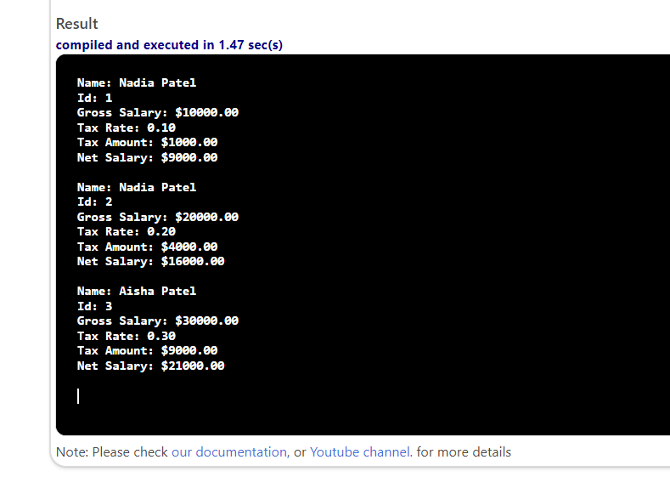

#include <iostream>
#include <iomanip>
using namespace std;

struct Employee
{
string name;
int id;
double grossSalary;
double taxRate;
double taxAmount;
double netSalary;
};

int main()
{

Employee emp1 = {"Nadia Patel", 1, 10000.00, 0.1};
Employee emp2 = {"Nadia Patel", 2, 20000.00, 0.2};
Employee emp3 = {"Aisha Patel", 3, 30000.00, 0.3};

emp1.taxAmount = emp1.grossSalary * emp1.taxRate;
emp1.netSalary = emp1.grossSalary - emp1.taxAmount;

emp2.taxAmount = emp2.grossSalary * emp2.taxRate;
emp2.netSalary = emp2.grossSalary - emp2.taxAmount;

emp3.taxAmount = emp3.grossSalary * emp3.taxRate;
emp3.netSalary = emp3.grossSalary - emp3.taxAmount;

cout << "Name: " << emp1.name << endl;
cout << "Id: " << emp1.id << endl;
cout << "Gross Salary: $" << fixed << setprecision(2) << emp1.grossSalary << endl;
cout << "Tax Rate: " << emp1.taxRate << endl;
cout << "Tax Amount: $" << fixed << setprecision(2) << emp1.taxAmount << endl;
cout << "Net Salary: $" << fixed << setprecision(2) << emp1.netSalary << endl << endl;

cout << "Name: " << emp2.name << endl;
cout << "Id: " << emp2.id << endl;
cout << "Gross Salary: $" << fixed << setprecision(2) << emp2.grossSalary << endl;
cout << "Tax Rate: " << emp2.taxRate << endl;
cout << "Tax Amount: $" << fixed << setprecision(2) << emp2.taxAmount << endl;
cout << "Net Salary: $" << fixed << setprecision(2) << emp2.netSalary << endl << endl;

cout << "Name: " << emp3.name << endl;
cout << "Id: " << emp3.id << endl;
cout << "Gross Salary: $" << fixed << setprecision(2) << emp3.grossSalary << endl;
cout << "Tax Rate: " << emp3.taxRate << endl;
cout << "Tax Amount: $" << fixed << setprecision(2) << emp3.taxAmount << endl;
cout << "Net Salary: $" << fixed << setprecision(2) << emp3.netSalary << endl << endl;

return 0;
}

